**GCCM installation instructions**

The target platform of this software is x64.

1. First, please download R and RStudio in the official website.

R website: https://www.r-project.org/

RStudio website: https://www.rstudio.com/products/rstudio/download/

1. Install the required R packages:
   1. Install the following R packages: parallel, foreach, doParallel, rgdal, and spdep.

install.packages(parallel)

install.packages(foreach)

install.packages(doParallel)

install.packages("spdep")

The rgdal 1.6-7 package can be installed locally by downloading it from the following website：

https://cran.r-project.org/src/contrib/Archive/rgdal/

* 1. Run the following command to check whether the installation is successful:

library(parallel)

library(foreach)

library(doParallel)

library(rgdal)

library("spdep")

1. Then create a new system environment variable naming “R_HOME” with the value of home path of R language, For example D:\Program Files\R\R-4.3.1\R-4.3.1. Then create a new system environment variable naming “R_PATH” with the value of home path of R language, For example D:\Program Files\R\R-4.3.1\R-4.3.1\bin\x64. Note Do not set Chinese characters in the path.

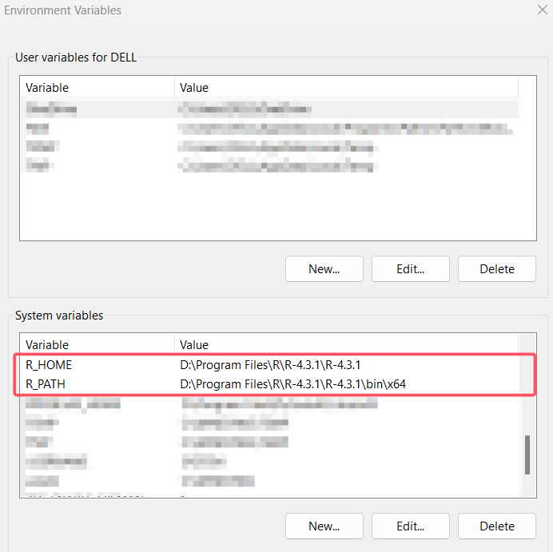

1. Click ‘setup.exe’ under the folder ‘…\GCCMSetup\Release’ to install this software.
2. Click ‘GCCMV1.exe’ under your installation path to start the software. Next, Select the method about linearity that you want, and place the ‘GCCMRcode’ folder under the path in the prompt box, for example in tips below, you should put the ‘GCCMRcode’ folder under ‘E:\’ folder.

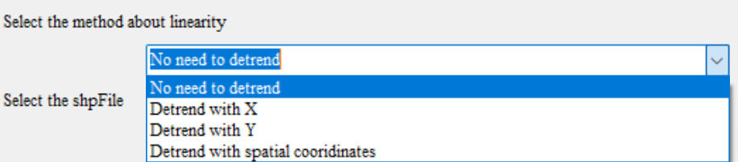 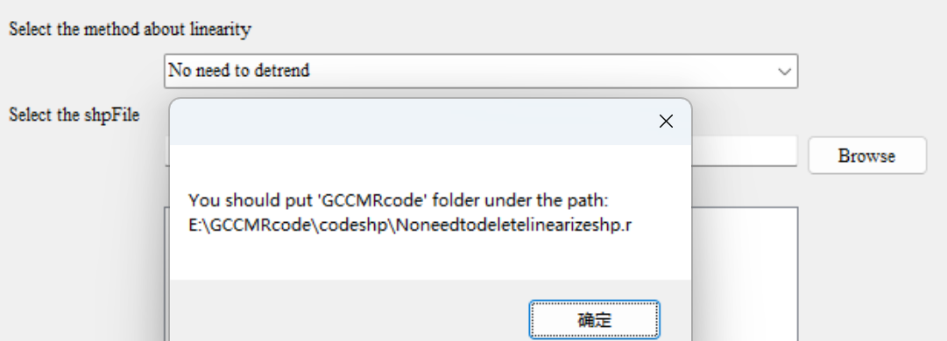

1. The panel is divided into two parts. If your original data is vector (shp), please use the left side of the panel and click Run after filling in the parameters; if your source data is raster (tif), please use the right side of the panel and click run after filling in the parameters.

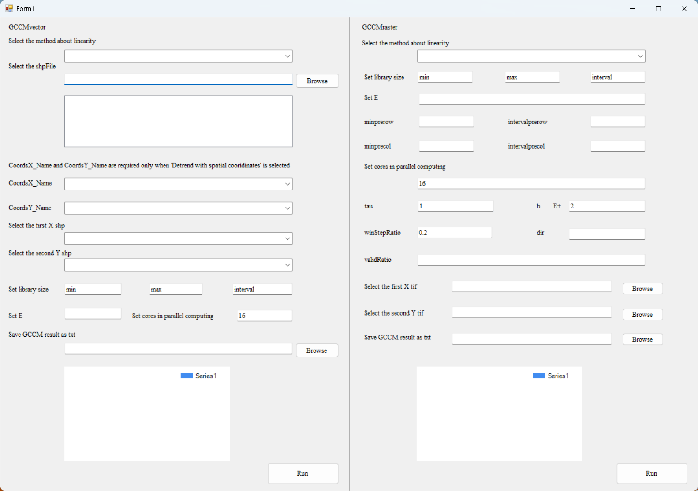

1. Parameter description of GCCMraster on the right side of the panel:
   1. Set library size: the sizes of libs to be calculated, they will appears at the horizontal axis;
   2. Set E: is the number of spatial lags used to construct the embedding;
   3. Set minprerow, intervalprerow, minprecol, intervalprecol:

predRows<-seq(minprerow, totalRow, intervalprerow)

predCols<-seq(minprecol, totalCol, intervalprecol)

To save the computation time, not every pixels are predict. The results are almost the same due to the spatial autocorrelation. If computation resources are enough, the minprerow, intervalprerow, minprecol and intervalprecol can all be set to 1.

* 1. Set cores in parallel computing: the number of cores can be used for parallel computing;
  2. tau: is the step of spatial lags. If tau=1, the first ring around the focus unit is used as the when E=1; while if tau=2, the second ring around the focus unit is used as the when E=1;
  3. b: number of nearest neighbors to use for prediction;
  4. winStepRatio: is a speedup parameter. In each prediction, a sliding window with the lib_size is used to confine the number of points in the state space. If the matrix is very large, it is time consuming. We can increase the sliding step with winStepRatio. The winStepRatio will be multiplied with the width/height to set the sliding steps
  5. dir: direction parameter for anisotropy. It used to select spatial units from spatial lags to be used to reconstruct the state sapce. That means only spatial lags in the direction defined by dir take into the reconstruction of the state space. dir=0, all directions are considered. dir=1, Northeast; dir=2, North; dir=3, Northwest; dir=4, West; dir=5, Southwest; dir=6, South; dir=7, Southeast; dir=8, East; dir can also be a vector with more than one directions. For example, dir=1 2, then both Northeast and North will be used; dir=1 5,Northeast and Southwest; if you want to input multiple directions at the same time, you can separate numbers with Spaces, such as 1 3 4 (separated by Spaces);
  6. validRatio: is the parameters to handle NA values. When the study area have too many NA (or Nodata) values, we would get NA results. To handle the NA values，we will neglect the NA values of target variables. But it will also causes NA results or unstable predictions. So the validRatio is used to expand the neighbors to farther sate points: maxDistacne+meanDistance*validRatio，where maxDistacne is the largest distance of the closest b neighbors, the meanDistance is the average distance f the closest b neighbors. If validRatio=0.01, then the candidates set were expanded to 0.01*meanDistance. Then after removing NA values of the closest b neighbors, farther sate points in candidates set could be used to replenish.

1. Click ‘GCCMSetup.msi’ under the folder ‘…\GCCMSetup\Release’ to uninstall.